Preparing SQL Server Replicas for Backup to Azure File Share

Make sure that the following PowerShell scripts are in F:\DBA\CleanupAzureBkup folder in every replica in the environment.cost
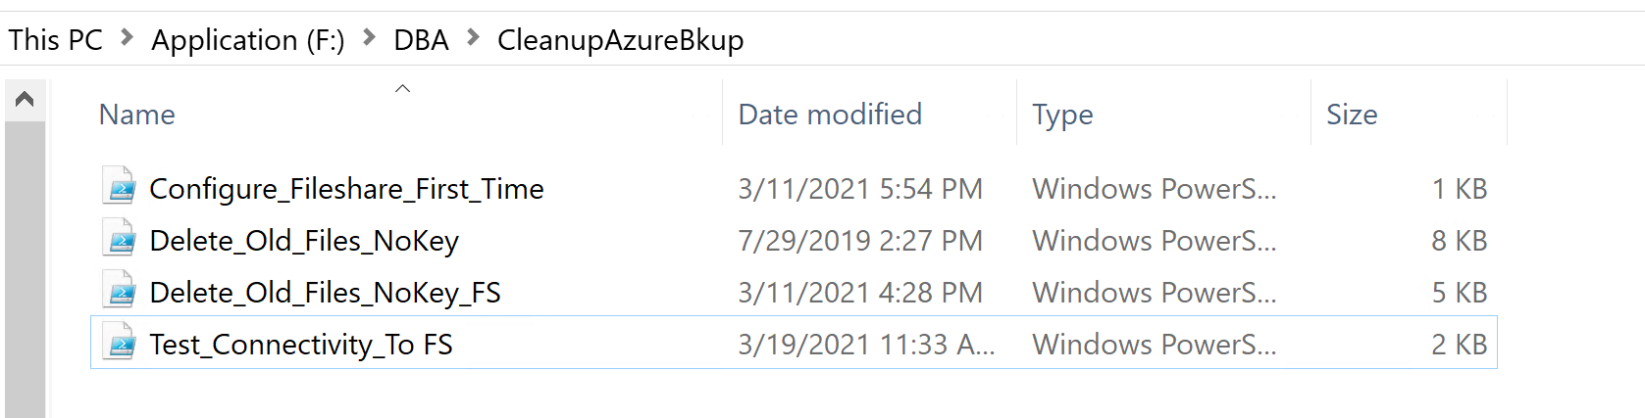

Testing Access to Azure File shares from Windows
- Open Windows PowerShell ISE (not as Administrator !!!)
- Open File Test_Connectivity_To FS.ps1
- Put proper values for storage account name and Primary Key that you saved in previous steps when you created Azure File Share.
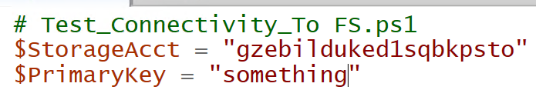
- Execute script with new values.
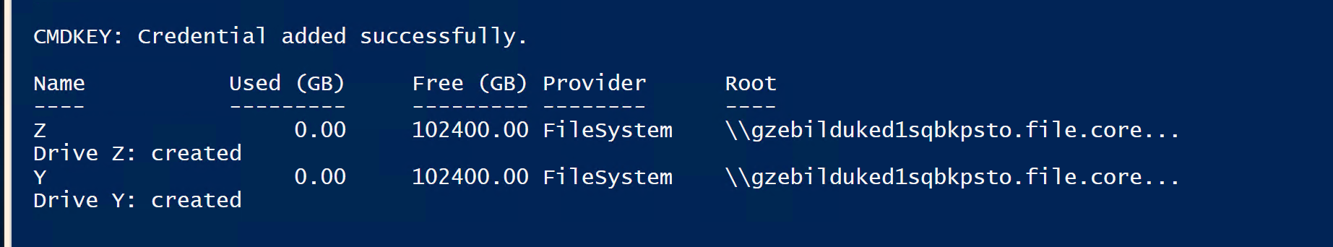
- Verify in File Explorer that network shares are created.
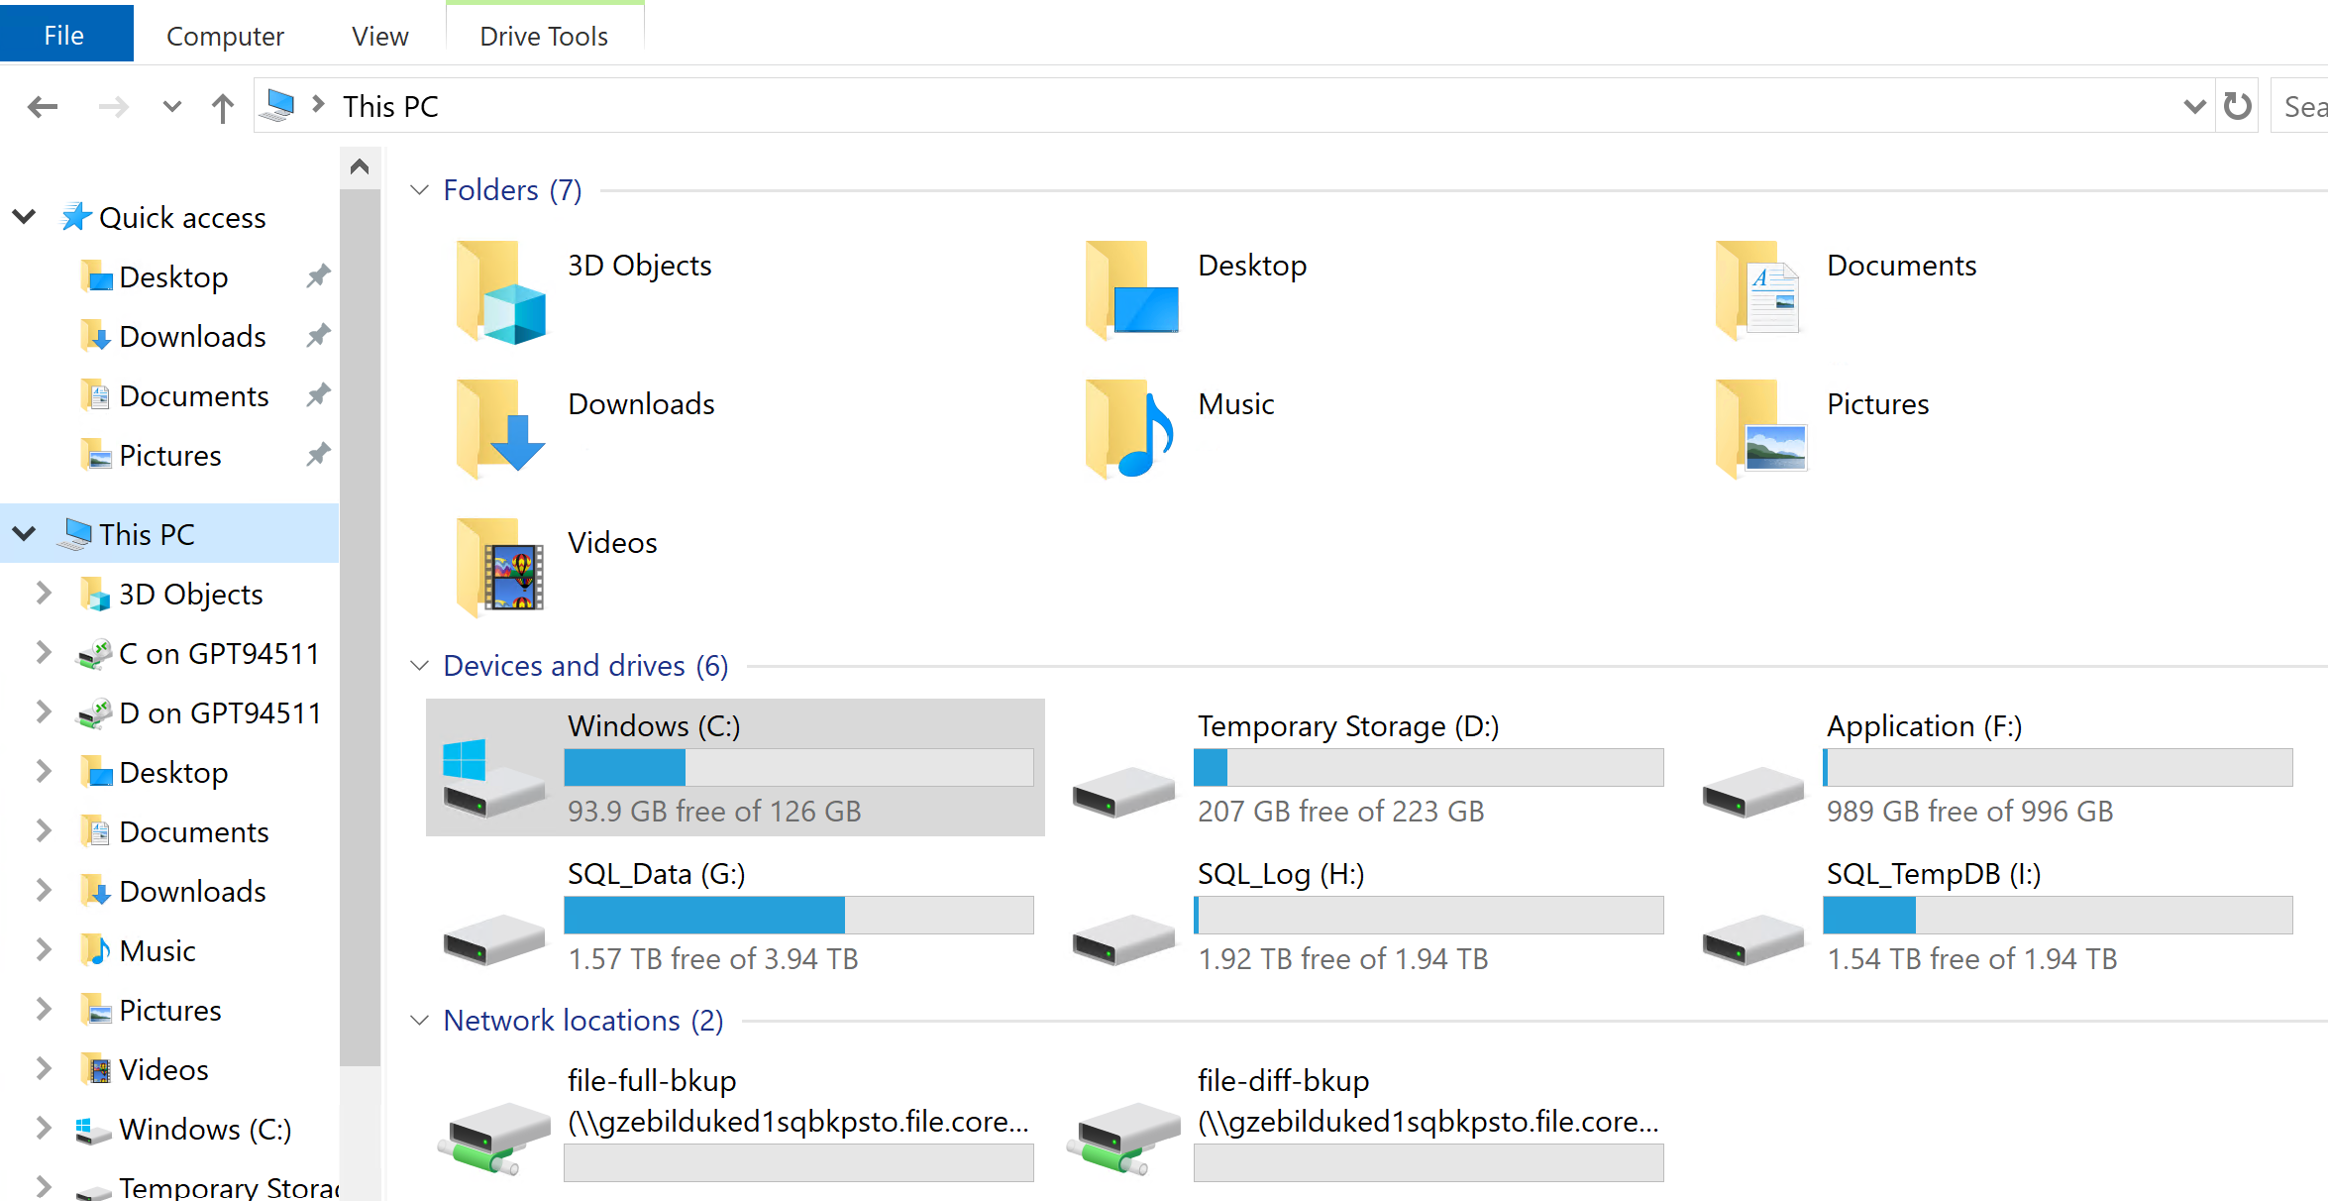

Granting Access to File Share to SQL Server

Make sure that the following scripts are in F:\DBA\Microsoft\AzureFileshareBackup folder in every replica in the environment.
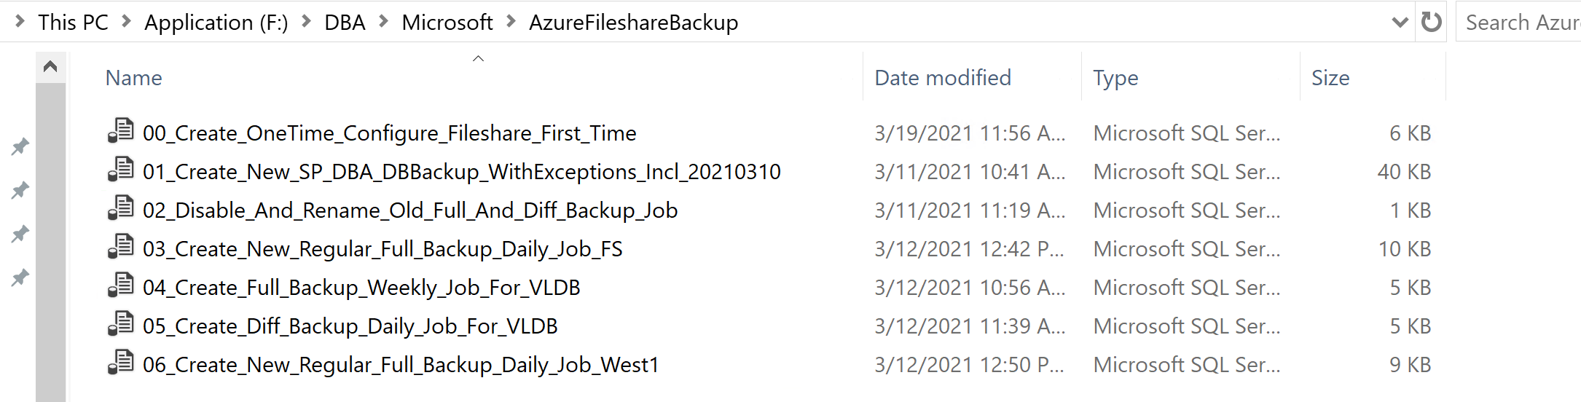
- In SSMS open file 00_Create_OneTime_Configure_Fileshare_First_Time.sql
and enter proper name of storage account. Execute the script.
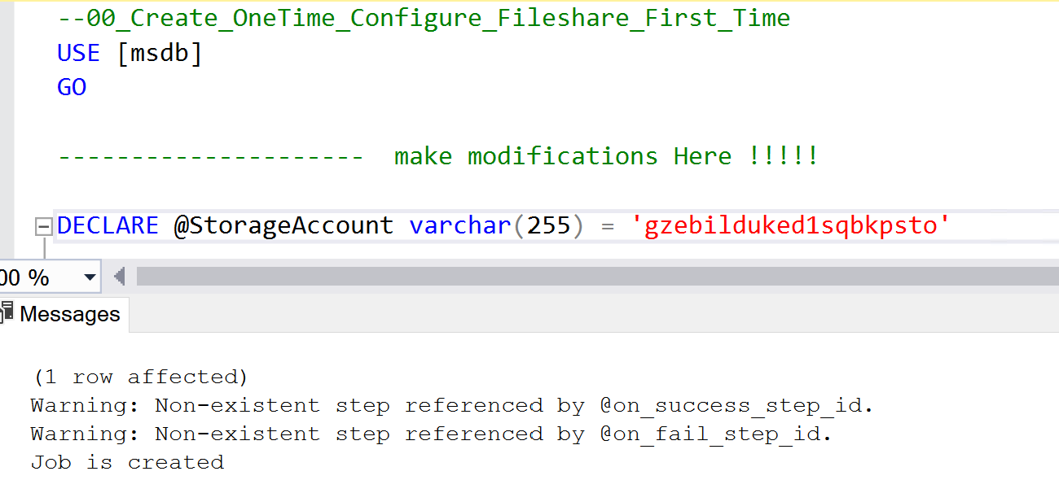
This script creates job [OneTime_Configure_Fileshare_First_Time] that was just executed. Job should be executed only. It permanently grants permission to SQL Server to Azure File share.
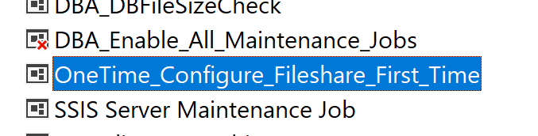
- Repeat this step in all replicas.

Configuring Backup Jobs to Azure Fileshare

- In SSMS Execute script 01_Create_New_SP_DBA_DBBackup_WithExceptions_Incl_20210310.sql
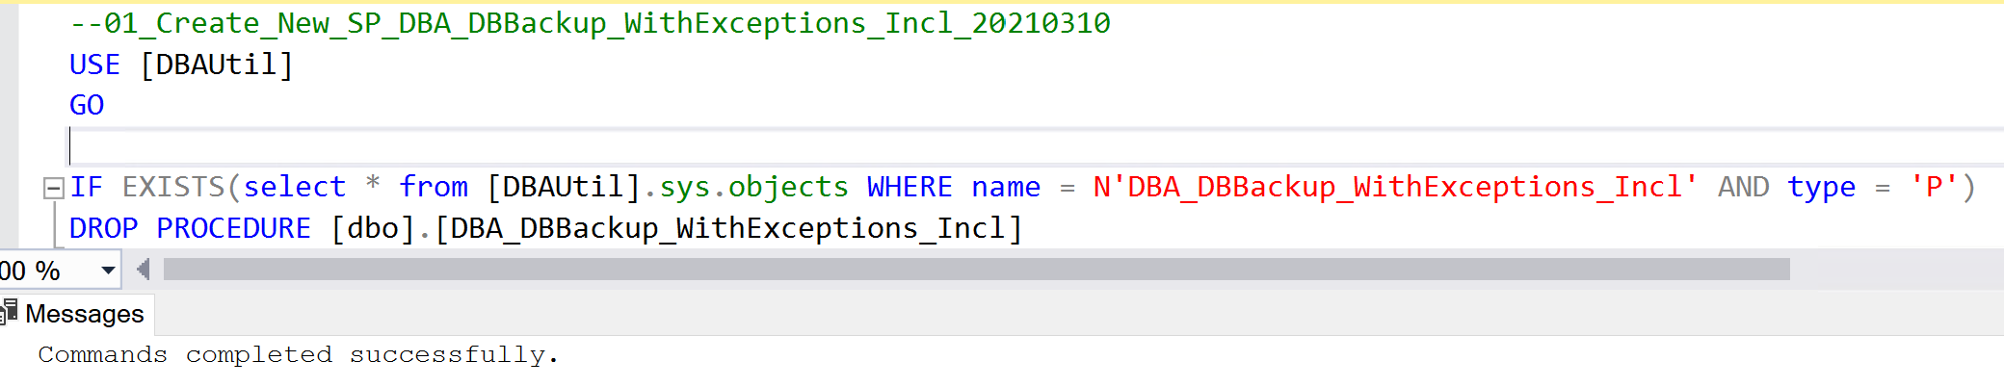
This script deploys new version of stored procedure DBA_DBBackup_WithExceptions_Incl that performs Full and Differential backups.
- Execute script 02_Disable_And_Rename_Old_Full_And_Diff_Backup_Job.sql .
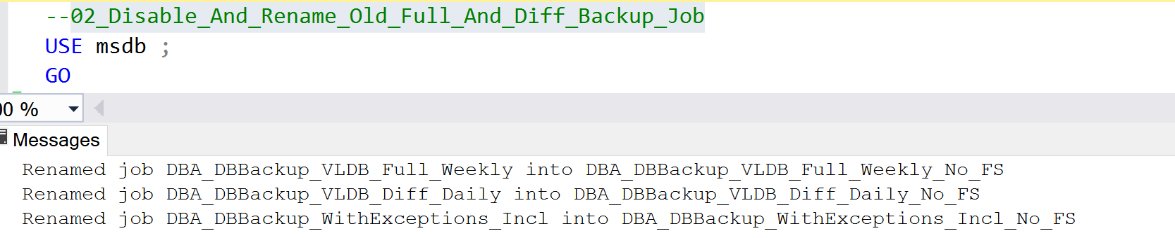
This script renames and disables old jobs and keeps their history.
- Open script 03_Create_New_Regular_Full_Backup_Daily_Job_FS.sql and modify value for variable @StorageAccountName. If necessary, add additional databases into excluded list in @ExcludeDatabasesList variable which are on weekly backup schedule. As of now, only Billing database is on weekly backup cycle.
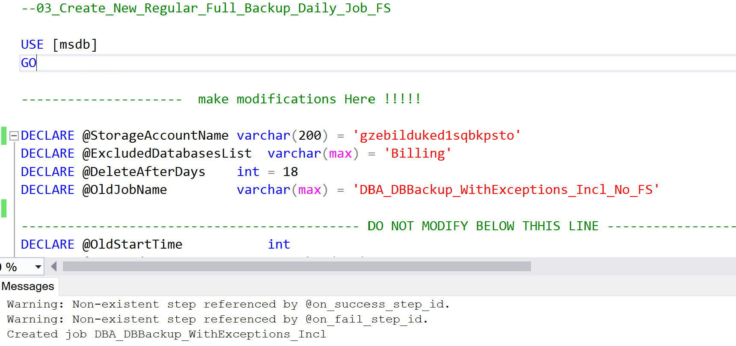
This script creates new job to perform daily Full backups for all databases on daily cycle.
- Execute script 04_Create_Full_Backup_Weekly_Job_For_VLDB.sql and modify value for variable @StorageAccountName. If necessary, add additional databases into included list in @IncludeDatabasesList variable which are on weekly backup schedule. As of now, only Billing database is on weekly backup cycle.
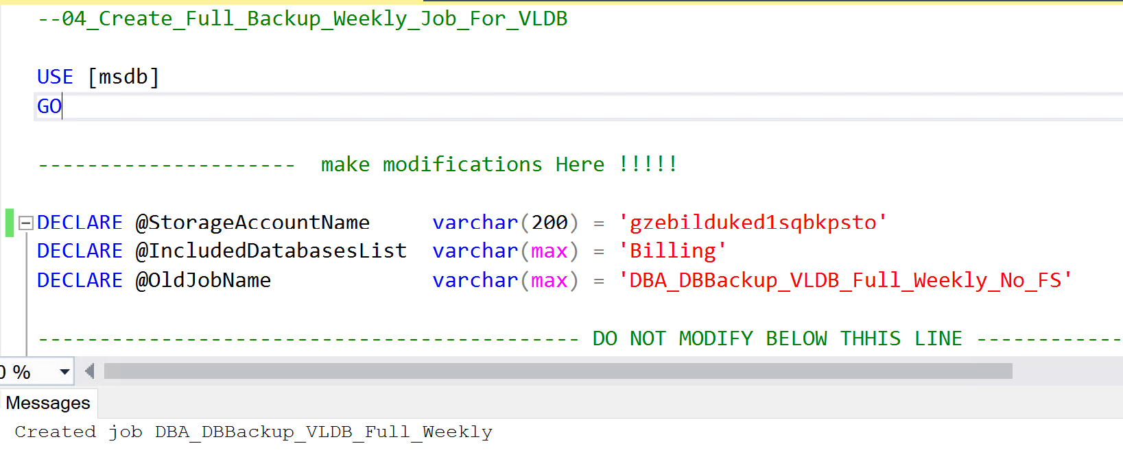
This script creates new job to perform weekly Full backups for all databases on weekly cycle.
- Execute script 05_Create_Diff_Backup_Daily_Job_For_VLDB.sql and modify value for variable @StorageAccountName. If necessary, add additional databases into included list in @IncludeDatabasesList variable which are on weekly backup schedule. As of now, only Billing database is on weekly backup cycle. Optionally, you may send both Full and differential backups into a single file share file-full-bkup. In this case, set value for @SeparateFSForDiff to 0.
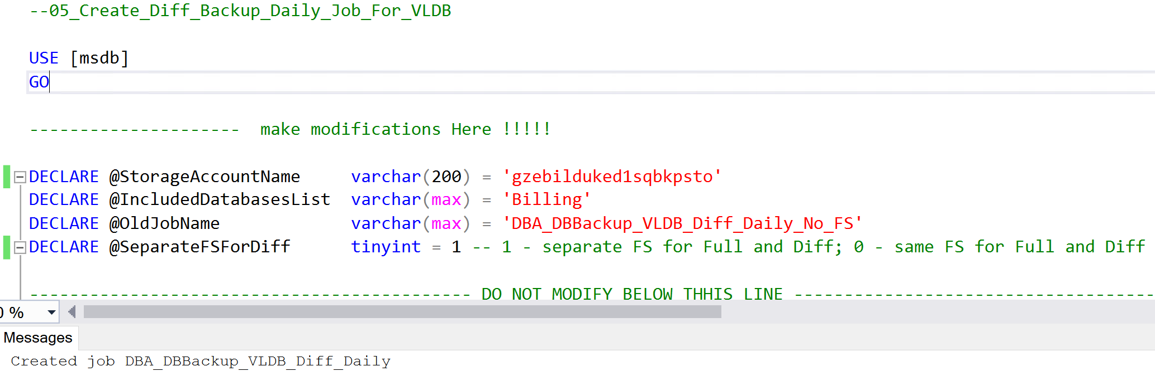
This script creates a new job to perform daily Differential backups for all databases on weekly cycle.
- Repeat steps 2-5 in every replica in the East region.
- If the environment has replicas in West region, execute script in every West-based replica 06_Create_New_Regular_Full_Backup_Daily_Job_West1.sql. Make sure to modify value for variable @StorageAccountName. If necessary, add additional databases into excluded list in @ExcludeDatabasesList variable which are on weekly backup schedule. As of now, only Billing database is on weekly backup cycle.

